
RAMAIAH
INSTITUTE OF TECHNOLOGY
USN | 1 | M | S

(Autonomous Institute, Affiliated to VTU)
Bangalore – 560 054

MAKEUP EXAMINATIONS – MARCH 2017

Course & Branch | : | Electrical & Electronics Engineering. | Semester | : | V
Subject | : | Control Systems | Max. Marks | : | 100
Subject Code | : | EE502 | Duration | : | 3 Hrs

Instructions to the Candidates:
- Answer one full question from each unit.

 |  | UNIT-I
1. | a) | Consider the system shown in fig.1(a), R, L, C are electrical parameters while K, M, B are mechanical parameters as shown. Find the T.F. X(s)/E₁(s), for the system where E₁(t) is input voltage while x(t) is the output displacement. | CO1 | (10)
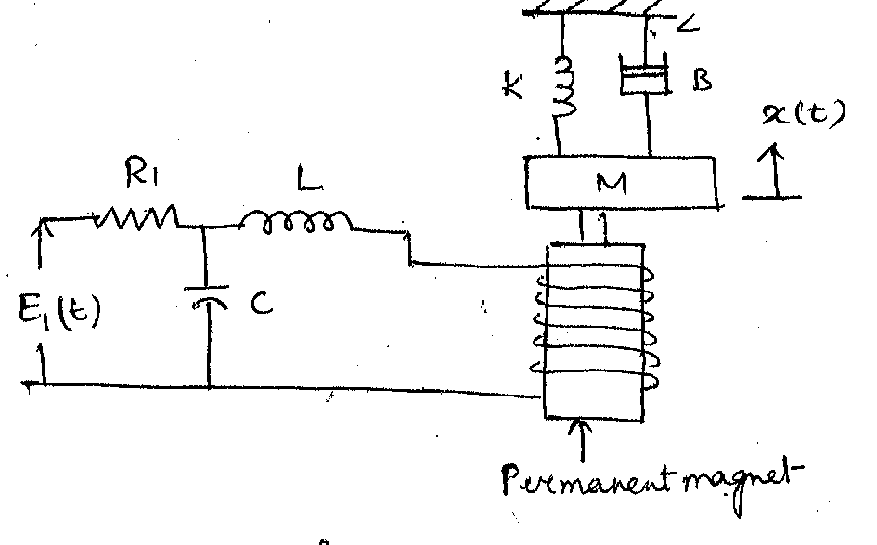
Fig 1 (a)
 | b) | Draw the F-V and F-I analogous electric circuit of the rotational systems shown in fig 1b  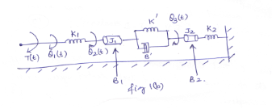 | CO1 | (10)
2. | a) | Define control system and bring out the clear differentiation between the open loop and closed loop control system with relevant examples. | CO1 | (08)
 | b) | Draw the F-V and F-I analogous electric circuit for the mechanical system shown in Fig 2b).  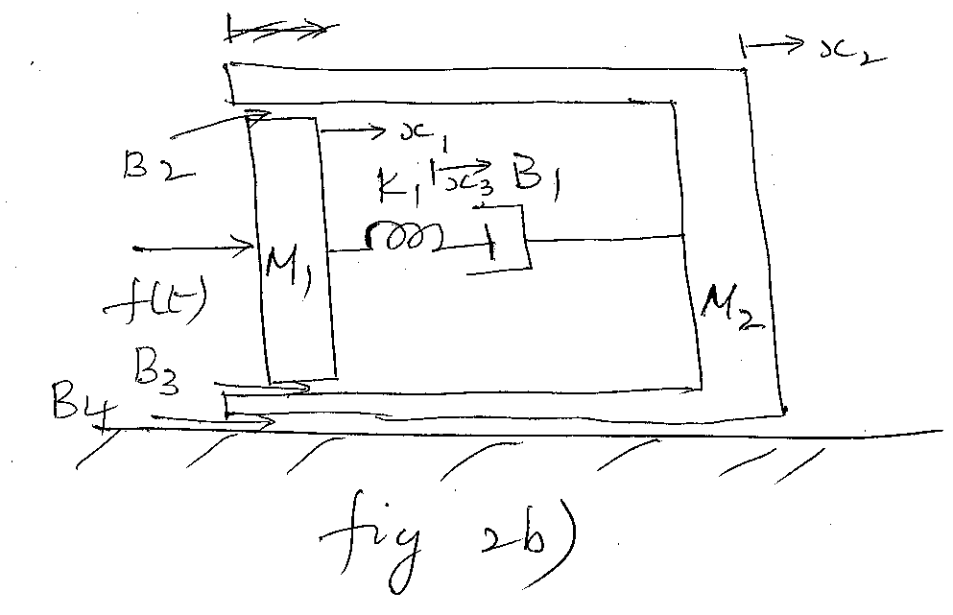 | CO1 | (12)
 |  | UNIT- II
3. | a) | Define i) Peak Overshoot ii) Peak Time with respect to an under damped system. Hence derive the expression for the same. | CO2 | (10)
 | b) | For the following closed loop system,  - Draw SFG  ii) Find the TF  - Find the settling time for system response to be within 2% of the final value when unit step disturbance D(s) occurs.  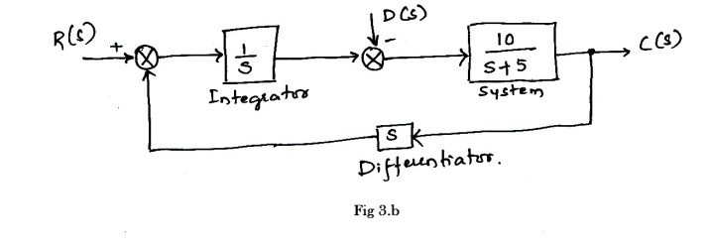 | CO2 | (10)
4. | a) | Obtain the transfer function from following circuit diagram  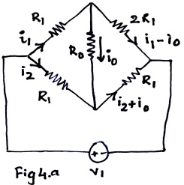 | CO2 | (10)
 | b) | Define steady state error? With usual notations, derive the expression for steady state error and positional error constant of a negative feedback system. | CO2 | (10)
 |  | UNIT- III
5. | a) | State and explain RH criterion of stability. What are its limitations? | CO3 | (08)
 | b) | Plot the root locus of the system with OLTF , Show that part of root locus of system is a circle. | CO3 | (12)
6. | a) | State the steps of construction of root-locus from OLTF. | CO3 | (10)
 | b) | Plot the root locus for the system given by: . Comment on stability. | CO3 | (10)
 |  | UNIT- IV
7. | a) | Define i) Resonant peak ii) Resonant frequency iii) Bandwidth iv) Cut off rate. | CO4 | (08)
 | b) | A unity negative feedback system is characterized by, .  - Find the values of K and so that and  - For the above values of K and, find settling time and BW of the system. | CO4 | (12)
8. | a) | Using Nyquist stability criterion, find the range of K for closed loop stability. The OLTF is given by | CO4 | (10)
 | b) | A unit step input is applied to unity negative feedback system having OLTF .  Determine K and T to have peak overshoot and resonant frequency . Also find resonant peak . | CO4 | (10)
 |  | UNIT- V
9. | a) | Obtain the Bode plot of unity negative feedback system, whose OLTF is . Hence find the stability of the system. | CO4 | (12)
 | b) | Explain the need for designing of a compensator with at least two relevant practical example. | CO5 | (08)
10. | a) | Define i) Gain Margin ii) Phase margin of a system. Hence mention the conditions for stability of a system. | CO4 | (06)
 | b) | Obtain the transfer function of the system whose Bode plot is as shown below.  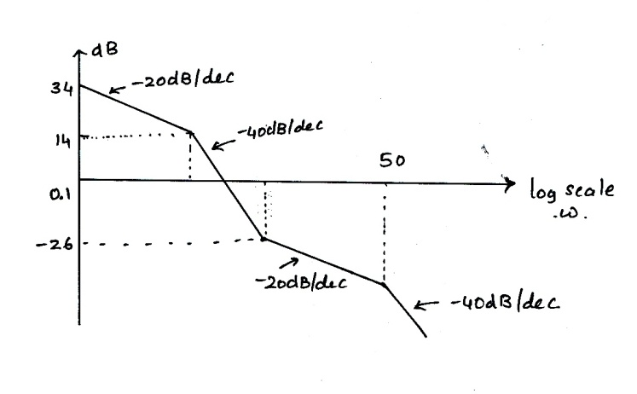 | CO4 | (06)
 | c) | Obtain the transfer function of a lead compensator for φ_{m}=45⁰ and f_{m}=3KHz. Assume C=10nF. | CO4 | (08)

****************

